Jet thruster on RM 1270 no 13 Schnufao

A little wind in a tiny marina and the docking will come a problem with the flat designed hull of the speedily RM 1270. Without speed the bow of a RM 1270 isn’t any more under control. For this reason, I chose the Jet thruster 50 for my boat. Due to the shape of the hull the only way to have the reaction point near the bow. Another point, I don’t like weight in the bow of a sailboat, with the Jet thruster the heavy pump and the batteries can be installed near the center of the boat. With a good friend of mine in three days we installed the Jet thruster, two days in water, for electric and electronic installation and some openings inside the hull for passing the pipes. In one day out of the water, we drilled the 90mm inlet hole and the two 60mm jet holes and fixed all with a lot of Sikaflex 291. Ones in the water after 24 hours curing of the Sikaflex on the first push bottom the system worked perfect.

The following photos and video give more explanations.

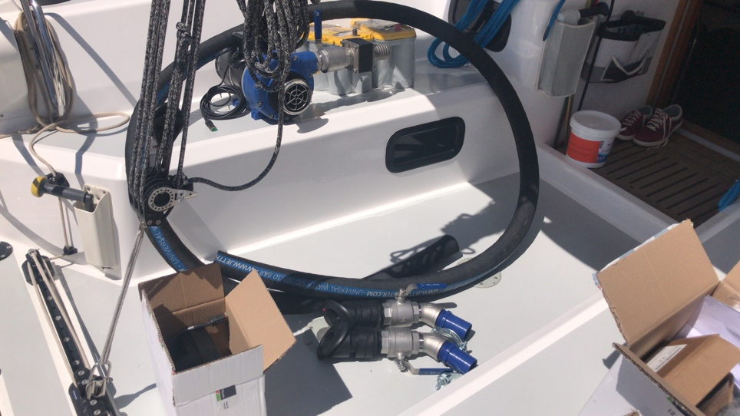 lay out of delivery

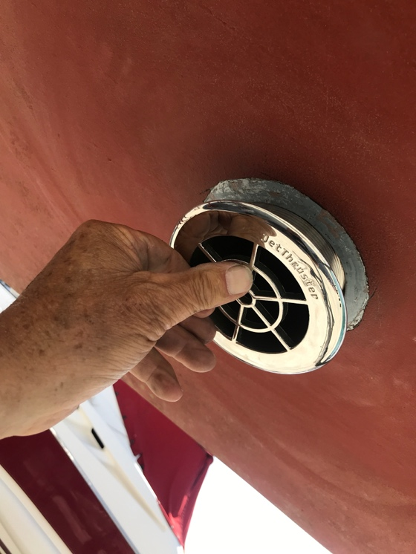 Inlet holes with entry device

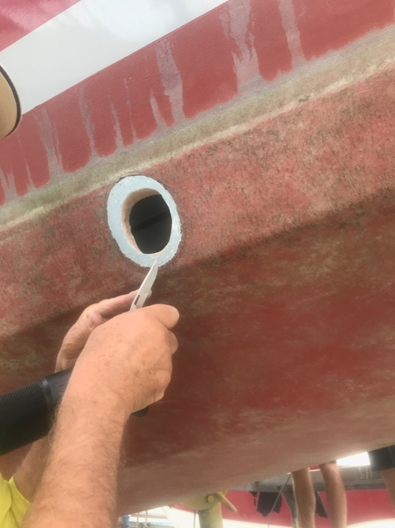 preparing starboard hole for jet

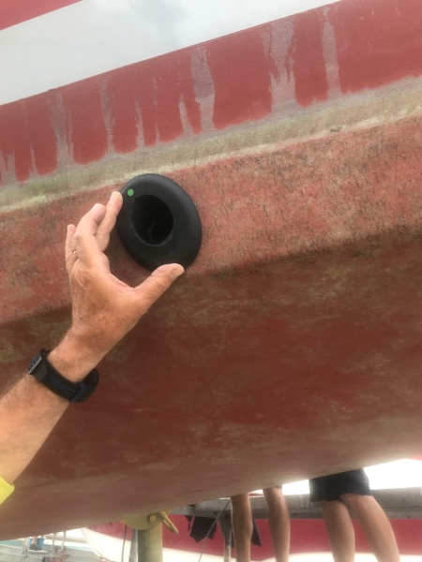 placing of jet, horizontal and 90 degrees to boat axle

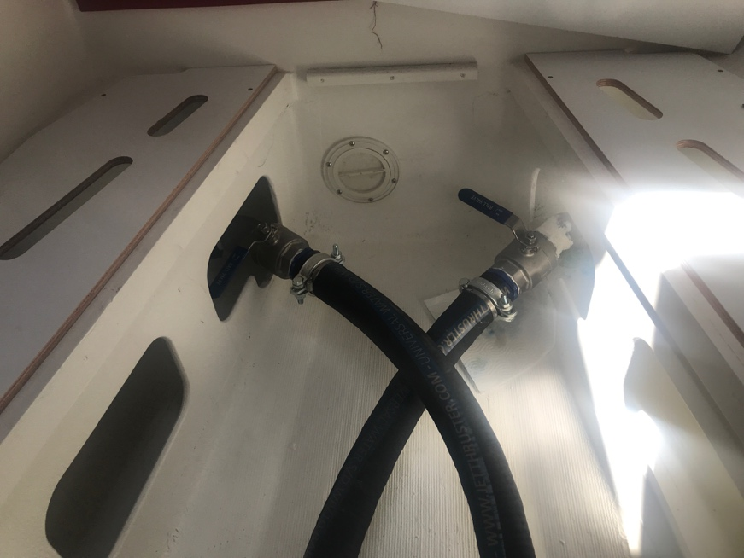 Jet nozzles inside the boat

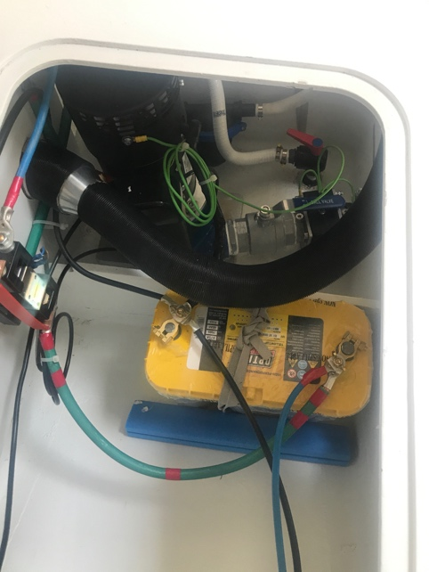 6 kW pump with two Optima batteries very closed together

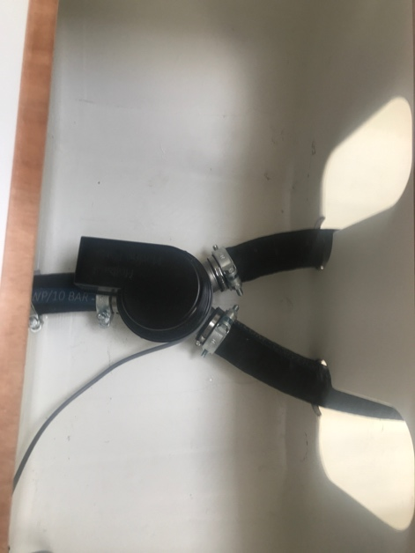 3 way valve

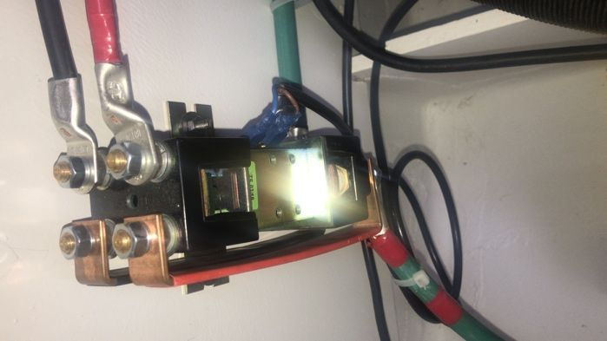 special device for charging with 12 V but working with 24 V
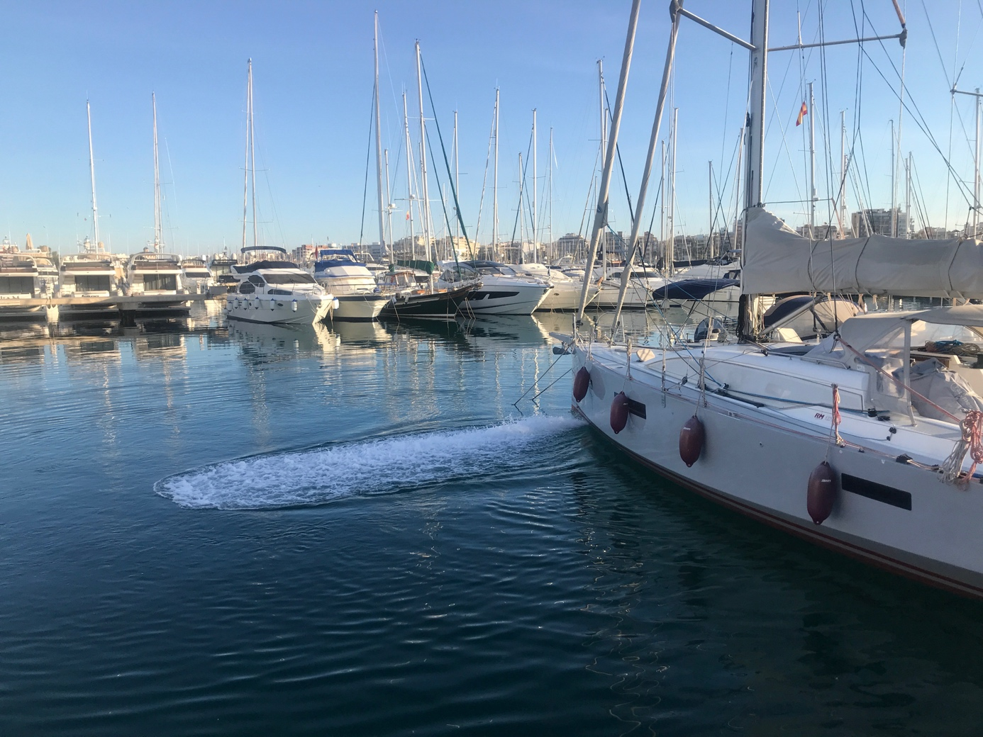

Very powerful jet, once I shall try as a Jacuzzi

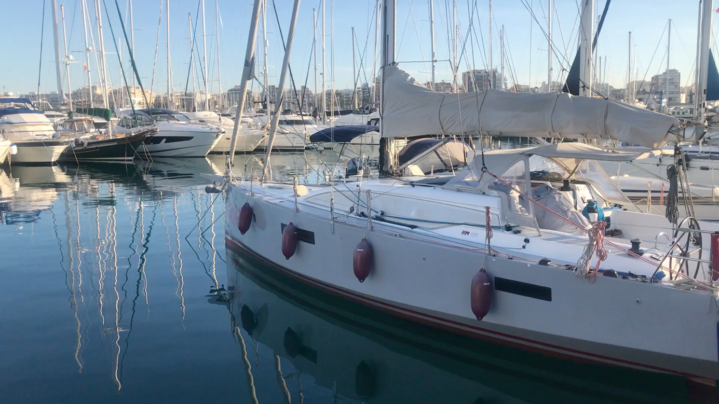

Video

Domingo Zaengerle May 2019

